Indirect Object as a Verb Complement

✅ What Is an Indirect Object?
# Source: AI Source: Provided by: [Data Path: Persons Table -> ID Column: 1, Name_En Column: Motasem Essam] -> From: [ChatGPT] on [8/4/2025]
An indirect object is a noun or pronoun that receives the direct object or is the beneficiary of the action. When used with certain verbs, it helps complete the verb's meaning, and is thus considered a verb complement in broader grammar.

🔸 Structure:
# Source: AI Source: Provided by: [Data Path: Persons Table -> ID Column: 1, Name_En Column: Motasem Essam] -> From: [ChatGPT] on [8/4/2025]
There are two main patterns:
- Verb + Indirect Object + Direct Object
→ She gave him a gift.
- Verb + Direct Object + Prepositional Phrase (to/for + Indirect Object)
→ She gave a gift to him.

🔸 Examples:
# Source: AI Source: Provided by: [Data Path: Persons Table -> ID Column: 1, Name_En Column: Motasem Essam] -> From: [ChatGPT] on [8/4/2025]
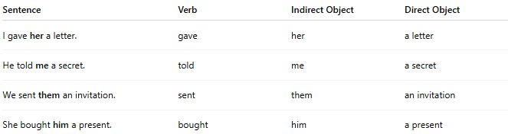
Sentence | Verb | Indirect Object | Direct Object
I gave her a letter. | gave | her | a letter
He told me a secret. | told | me | a secret
We sent them an invitation. | sent | them | an invitation
She bought him a present. | bought | him | a present

🔸 Why It's a Verb Complement:
# Source: AI Source: Provided by: [Data Path: Persons Table -> ID Column: 1, Name_En Column: Motasem Essam] -> From: [ChatGPT] on [8/4/2025]
The indirect object is essential to the meaning of many ditransitive verbs—those that take both a direct and indirect object. It completes the verb by identifying to whom or for whom the action is performed.
🟢 Example:
- ✅ "I sent her a message."
- ❌ "I sent a message." (grammatically fine, but missing key information)

